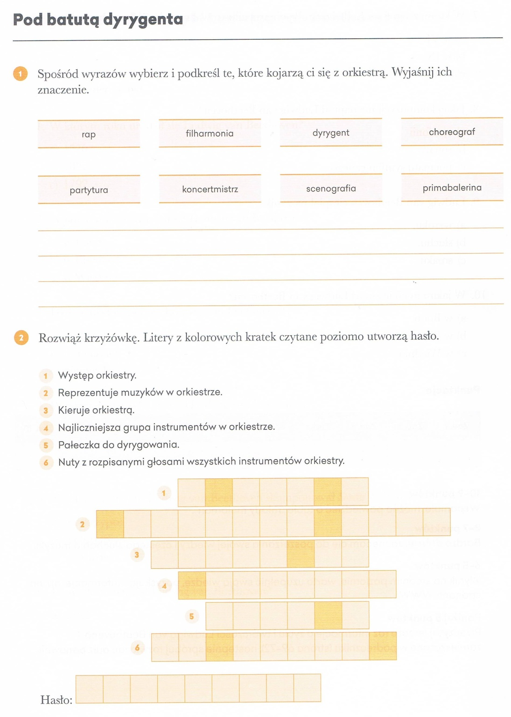
Na podstawie podręcznika (str. 82-83) wyjaśnij pojęcia:
Orkiestra to: ………………………………………………………………………………………………
……………………………………………………………………………………………………………………
……………………………………………………………………………………………………………………

Dyrygent to: ……………………………………………………………………………………………….
……………………………………………………………………………………………………………………

Batuta to: ……………………………………………….…………………………………………………
……………………………………………………………………………………………………………………

Koncertmistrz to: ……………………………………………………………………………………..
……………………………………………………………………………………………………………………
……………………………………………………………………………………………………………………

Filharmonia to: …………………………………………………………………………………………
……………………………………………………………………………………………………………………

